

SESSION 3.1: SIR MELVIN BURACHO REVIEW CENTER (MAY 15, 2026)
GENERAL EDUCATION
(English)
https://www.facebook.com/share/v/18ii5MpkLs/

BASIC SENTENCE PATTERNS

- Subject – Intransitive Verb
S: Subject (the performer of the action)
IV: Intransitive Verb (action verb that needs no direct object)

Example: The sun rises.
S IV

Tip: To spot an intransitive verb, ask "Who?" or "What?" right after the verb. If the question doesn't make sense or has no answer in the sentence, the verb needs no direct object, meaning it is intransitive.

Example: The sun rises (what?) (makes no sense)
The sun rises (who?) (makes no sense)

- Subject + Linking Verb + Predicate Adjective/Noun
S: Subject (the performer of the action)
LV: Linking Verb (connects the subject to more information)
C: Complement (completes the meaning of the subject)
- PA: Predicate Adjective (adjective that describes the subject)
- PN: Predicate Noun / Nominative (noun that renames the subject)

Example: The soup smells delicious. You are a teacher.
S LV C (PA) S LV C(PN)

Note: To spot a linking verb, replace it with an equal sign (=) or "is/are." If the sentence still makes sense and the subject equals the description, it is a linking verb.

Example: The soup = delicious (still makes sense)
You are a teacher / You = a teacher (still makes sense)

- Subject + Transitive Verb + Direct Object
S: Subject (the performer of the action)
TV: Transitive Verb (an action verb that requires a direct object) (kabaliktaran ni IV)
DO: Direct Object (the person or thing receiving the action of the verb)

Example: Alex writes poems.
S TV DO

Note: To spot a transitive verb, ask "What?" or "Who?" right after the verb. If the sentence answers that question, the verb is transitive, and that answer is your direct object.

Example: Alex writes (what?) poems. (the question what is answered with direct object)
- Subject + Transitive Verb + Indirect Object + Direct Object
S: Subject (the performer of the action)
TV: Transitive Verb (an action verb that requires a direct object) (kabaliktaran ni IV)
DO: Direct Object (the person or thing receiving the action of the verb)
IO: Indirect Object (the person or thing to whom or for whom the action is done)

Example: I gave my friend a gift.
S TV IO DO

Note: To find the indirect object, ask "To whom?" or "For whom?" about the direct object. The person or thing that answers this question is the indirect object.

Example: I gave my friend a gift. (For whom is the gift? For my friend)

- Subject + Transitive Verb + Direct Object + Object of Preposition
S: Subject (the performer of the action)
TV: Transitive Verb (an action verb that requires a direct object) (kabaliktaran ni IV)
DO: Direct Object (the person or thing receiving the action of the verb)
OP: Object of the Preposition (the noun or pronoun that follows a preposition)

Example: I wrote a poem under the tree.
S TV DO OP

Note: To find the preposition and its object, ask "Where?" or "When?" right after the direct object. The location or time phrase that answers this will contain the preposition and the object of the preposition.

Example I wrote a poem (where?) under the tree. (question is answered)

- Subject + Transitive Verb + Direct Object + Object Complement
S: Subject (the performer of the action)
TV: Transitive Verb (an action verb that requires a direct object) (kabaliktaran ni IV)
DO: Direct Object (the person or thing receiving the action of the verb)
OC: Object Complement (a word that modifies, describes, or renames the Direct Object)

Example: The teacher made the lesson interesting.
S TV DO OC

Note: The object complement always comes right after the direct object. To spot it, ask "What?" or "How?" about the direct object to see what it became or how it is being described.

Example: The teacher made the lesson (what?) interesting. (question is answered)

The underlined phrase in the following sentence is a/ an_____________. "She called her best friend a green-eyed monster."
- indirect object
- objective complement
- direct object
- subjective complement

Which BEST describes the gerund in the sentence, “Tala’s life-threatening hobby is sky diving”?
- appositive
- objective complement
- direct object
- subjective complement

Note:

A gerund is an "-ing" word that acts completely like a noun (a thing, activity, or concept) instead of an action verb. It looks like a verb, but it functions like a noun. To test it, replace the "-ing" word with the pronoun "it". If the sentence still works, it is a gerund.

An appositive is a noun or a phrase that sits right next to another noun to rename it or give extra information about it.

Which is the function of the gerund in the given sentence? “Reading maketh a full man”
- predicate nominative
- appositive
- direct object
- subject

PARTS OF SPEECH

Nouns
A noun is a word that names a person, place, thing, or idea.

Types of Nouns
Noun Type | Definition from Slide | Everyday Examples
Proper Noun | specific name | Manila, Jollibee, Maria, Samsung, Sunday (Always capitalized!)
Common Noun | common name | city, restaurant, girl, phone, day (General names, no capitals)
Collective Noun | group | family, team, class, audience, flock (One word for a collection of things/people)
Concrete Noun | physical object | table, coffee, dog, cell phone, rain (Things you can touch, see, smell, hear, or taste)
Abstract Noun | cannot be perceived (senses) | love, happiness, anger, time, education (Ideas, emotions, or concepts you cannot touch)
Countable Noun | can be counted | apple (two apples), car (three cars), book (five books)
Non-countable Noun | cannot be counted | water, rice, sand, information, money (Things you cannot count individually without a container or unit)

Pronouns
A pronoun is a word used to replace a noun to avoid repeating it.

Types of Pronoun
Pronoun Type | Definition from Slide | Slide Example | Simple Rule / Trick
Personal Pronoun | Substitutes proper nouns | She is an LPT. | Replaces basic names of people or things (I, you, he, she, it, we, they).
Reflexive Pronoun | The doer is also the receiver. | I praised myself for doing a good job. | Mandatory: If you remove it, the sentence breaks.
Intensive Pronoun | Used only for emphasis | The actor received the award herself. | Optional: If you remove it, the sentence still makes perfect sense.
Demonstrative Pronoun | Show, point, exhibit | These were the items I bought. | Points directly at items (This, That, These, Those).
Indefinite Pronoun | Does not refer to any person/thing | Only few committed to attend the online meeting. | Refers to general, non-specific amounts (Few, Someone, Everyone, Many, None).
Interrogative Pronoun | Used to ask questions | Who were lucky enough to hit the jackpot? | Question words used to stand in for a missing answer (Who, Which, What, Whom).
Distributive Pronoun | Denotes persons of things of group separately | Each student has to purchase an access card to the Millennium ball. | Looks at members of a group individually, one by one (Each, Either, Neither).
Relative Pronoun | Join clauses and relates | The man who claimed he can stop a calamity was mocked by people. | Glues two thoughts together by pointing back to a nearby noun (Who, Which, That, Whom).
Possessive Pronoun | Show possession or ownership | This hat is his. | Shows exactly who owns something (Mine, Yours, His, Hers, Ours, Theirs).

Adjective
An adjective is a describing word that gives more information about a noun or a pronoun.

Types of Adjectives
Adjective Type | Definition from Slide | Slide Example | Simple Rule / Trick
Demonstrative Adjective | Answers "The which"? | This car used to be his. | Points directly at a specific noun (This, That, These, Those + Noun).
Interrogative Adjective | Poses a question & needs a noun/pronoun | Which dress do you like? | Question words that must sit right in front of a noun (Which, What, Whose + Noun).
Cardinal Adjective | Describes the quantity (number) | I have nine siblings. | Regular counting numbers that show how many (One, Two, Three, Nine...).
Ordinal Adjective | Order of things | This is my first take for licensure exam. | Numbers that show the position, sequence, or rank (First, Second, Third, Last...).
Coordinate Adjective | Small groups of adjectives | I wore a black and white shirt yesterday. | Two or more words describing the same noun equally (separated by "and" or a comma).
Possessive Adjective | Shows ownership | Is that your license? | Shows who owns the noun right after it (My, Your, His, Her, Our, Their).
Proper Adjective | Capitalized adjectives | I love Korean cuisine. | Created from a country or proper name. Always capitalized (Korean, Filipino, American).
Descriptive Adjective | Gives noun a quality or attribute | The cat got trapped in the filthy cage. | General words that paint a picture or show a condition (Filthy, Happy, Tall, Beautiful).

DRILL TIME:
Sentence | Answer
This is her next album. | Ordinal Adjective
Whose mother is here to see the principal? | Interrogative Adjective
This is the gown she wants. | Demonstrative Pronoun
I hope to have three albums. | Cardinal Adjective
She doesn't want that gown. | Demonstrative Adjective
What do you prefer? | Interrogative Pronoun
The man who called you is waiting. | Relative Pronoun

Verb
A verb is a word that shows action, occurrence, or state of being.

Forms of Verb
FINITE |  | NON-FINITE
BASE | PAST | PRESENT PARTICIPLE | PAST PARTICIPLE
write | wrote | writing | written
drive | drove | driving | driven

Note:
- Finite Verbs
These change their form based on time (past/present) or who is doing the action. They can act as the main verb of a sentence. ONE VERB

- Non-finite Verbs: These never change their form, no matter the time or person. They cannot be the main action verb by themselves; they need a helping verb or act like a noun/adjective. TWO VERBS

Types of Verbs
Verb Type | Slide Example | Simple Rule / Trick
Regular Verb | Agree, compare | Forms the past tense by simply adding -d or -ed (agreed, compared).
Irregular Verb | Quit, read, write | Forms the past tense in a strange or completely different way (wrote, drove).

Kinds of Verbs
Verb Kind | Slide Example | Simple Rule / Trick
Emphatic Verb | He did love me. | Uses do, does, or did right before a base verb to add strong emphasis.
Linking Verb | The teachers are kind. | Acts like an equals sign (=) connecting the subject to a description (Teachers = Kind).
Auxiliary Verb | The teacher is planning for her lessons. | A helping verb that pairs with a main action verb to show when it happened.
Transitive Verb | My boyfriend fixed my laptop. | An action verb that must have a receiver or target object (Fixed what? Laptop).
Intransitive Verb | You snore. | An action verb that stops with itself and needs no object (Snores what? Doesn't apply).
Ditransitive Verb | I promised you a good grade. | An action verb that takes two objects at the same time: a person (Indirect Object) and a thing (Direct Object).
Ergative Verb | I broke the glass. The glass broke. | A special verb that can switch sides. It can have an object (I broke the glass), or the object can become the subject all on its own (The glass broke).
Prepositional Verb | They dropped out of school. | An action verb that is glued to a direction word (preposition) to create a brand new combined meaning.

Preposition
A preposition is a word that shows the relationship between a noun (or pronoun) and other words in a sentence.

Types of Preposition
Preposition Type | What It Indicates | Everyday Examples | Sample Sentence
Preposition of Place / Location | Where something is physically located | in, on, at, under, behind, between, over, beside | The book is on the table.
Preposition of Time | When an event or action occurs | at, on, in, before, after, during, since, until | The review class starts at 9:00 AM.
Preposition of Direction / Movement | Where something is moving or heading | to, from, into, onto, through, across, toward | She walked into the testing room.

FOR PLACE (WHERE)

AT: SPECIFIC
(Specific Address, Precise Spot)

ON: MEDIUM
(Streets, Tables, Pages, Public Transport)

IN: BIG
(Country, City, Neighborhood, Enclosed Space)

Preposition | How to Use It | Examples
AT  (A specific point or destination) | Exact addresses, Specific buildings, Events | at 123 Main Street, at school, at the mall, at a party
ON  (On top of a surface) | Streets, Floors, Tables, Pages, Websites | on EDSA, on the second floor, on Facebook, on the desk
IN  (Inside an area / boundary) | Countries, Cities, Rooms, Cars, Containers | in the Philippines, in Manila, in the kitchen, in a box

Drill Time
Complete Sentence | Correct Preposition | Why
The villagers walk on foot to reach the main road. | on | Fixed Expression: We always say "on foot" when talking about walking.
She read an article in a magazine. | in | Inside print media: Articles, stories, or pictures are in a book, newspaper, or magazine.
The movie is showing on TV tonight. | on | Screens/Broadcasts: Anything shown via technology uses "on" (on TV, on the phone, on the radio).
Our drugstore is on Gov. Boyles Street. | on | Streets/Roads: Use "on" when naming a street without a specific building number.
They will meet at the office. | at | Specific Location: Use "at" for a general meeting point or workplace destination.
He fell asleep on the bus. | on | Public Transportation: Use "on" for large vehicles where you can stand up and walk (on a bus, train, plane).
I live at 143 Shanaell Street. | at | Specific Address: Because there is an exact house/building number ("143"), you must use "at".
We spent our vacation in Thailand. | in | Countries/Cities: Use "in" for large geographical regions, territories, countries, or cities.
I live at 143 Shanaell Street. | at | Specific Address: Because there is an exact house/building number ("143"), you must use "at".

FOR DATES (WHEN)

AT: SPECIFIC
(Exact Time, Precise Moments)

ON: MEDIUM
(Days, Dates)

IN: BIG
(Century, Year, Month, Season)

Preposition | How to Use It | Examples
AT  (Small / Exact Moment) | Clock times, Precise moments, Midnight/Noon, Specific ages | at 9:00 AM, at noon, at bedtime, at age 18
ON  (Medium / Specific Day) | Days of the week, Specific dates, Special holidays | on Monday, on September 25, on Christmas Day
IN  (Big / General) | Centuries, Years, Seasons, Months, Parts of the day | in 2026, in summer, in September, in the morning
FOR  (Time Duration) | Total span or length of time (Number + Time unit) | for 5 years, for two hours, for three months
SINCE  (Time Starting Point) | A specific pinpoint moment in the past when the action began | since 2018, since childhood, since Monday

Drill Time
Complete Sentence | Correct Preposition | Simple Explanation Why
We talked about school at dinner. | at | Meal times / Precise moments: Use "at" for specific shared daily routine moments.
See you on Monday. | on | Days of the week: Use "on" for specific days and explicit calendar dates.
We go swimming in the summer. | in | Seasons: Use "in" for broad, large blocks of time like seasons, months, and years.
I have lived here for 5 years. | for | Duration of time: Use "for" when counting the total amount of time (number + unit).
I have lived here since 2018. | since | Starting point: Use "since" to pinpoint the exact moment a past action started.
I got my first job at age 18. | at | Specific age / point: Use "at" when referring to a precise point in your life or milestone age.
The program starts at 8 A.M. | at | Clock time: Use "at" for exact hours and specific times on the clock.
Cindy has been steadily showing signs of recovery since Monday. | since | Starting point with perfect tense: The phrase "has been showing" indicates an action that started in the past and continues. Use "since" to point to that starting day (Monday).

Conjunction
A conjunction is a connector word used to glue words, phrases, or sentences together.

Types of Conjunctions
Conjunction Type | Definition / Clue | Example | Simple Rule / Trick
Coordinating Conjunction | FANBOYS  (for, and, nor, but, or, yet, so) | Joseph has to work late night, so he can not make it to the party. | Glues two independent sentences together that are equally important.
Subordinating Conjunction | Independent clause + dependent clause | We went camping although it was very cold. | Connects a main sentence to an incomplete "extra detail" sentence.
Correlative Conjunction | May ka-PAIR  (either...or, neither...nor, such...that, etc.) | Neither Jelmar nor Joseph can join the basketball league. | Two-part tags: Words that must always travel in matching pairs.

Adverb
An adverb is a word that modifies or describes a verb, an adjective, or another adverb.

Types of Adverb
Adverb Type | What It Answers | Example | Simple Rule / Trick
Adverb of Time | Kailan? (When?) | We recently purchased a brand new car. | Tells you exactly when an action took place.
Adverb of Place | Saan? (Where?) | The children are playing outside. | Tells you exactly where an action is happening.
Adverb of Manner | Paano? (How?) | He lazily sat on the sofa. | Describes the style or how an action is performed.
Adverb of Degree | Gaano? (How much?) | She is so excited to meet BINI. | Shows the intensity or to what extent a quality or action goes.
Adverb of Frequency | Gaano kadalas? (How often?) | I never eat breakfast because of my work schedule. | Tells you how many times or how often an action happens.

Interjection
An interjection is a word or short phrase used to express sudden or strong emotion.

Types of Interjections
Interjection Type | What It Indicates | Slide / Common Examples | Simple Rule / Trick
1. Interjection of Joy | Expresses happiness or celebration | Yay!, Hurray!, Woo-hoo! | Used when something great or successful happens.
2. Interjection of Surprise | Shows shock, amazement, or wonder | Wow!, Oh!, Huh!, What! | Used for unexpected news or incredible sights.
3. Interjection of Pain | Expresses sudden physical or emotional hurt | Ouch!, Ow!, Ah! | Your automatic reaction to getting hurt.
4. Interjection of Greeting | Used to start a conversation or acknowledge someone | Hello!, Hey!, Hi! | Standard friendly opening words.
5. Interjection of Approval | Shows encouragement, praise, or agreement | Bravo!, Well done!, Yes!, Right! | Used to cheer someone on or agree with a point.
6. Interjection of Sorrow / Grief | Used during sad, disappointing, or upsetting situations | Alas!, Oh no!, Uh-oh! | Expresses regret or realization of a mistake.
7. Interjection of Attention | Used to draw focus or quiet down an audience | Shh!, Listen!, Look!, Psst! | Signals others to notice something or stop talking.
8. Interjection of Doubt / Hesitation | Expresses uncertainty or thinking out loud | Hmm..., Er..., Um... | Used as filler words while you are figuring out an answer.

Article (Adjectives)
An article is a tiny word used right before a noun (markers of noun) to show whether you are talking about something specific or general.

Types of Article
Article Type | The Words | How to Use It | Practical Examples
Definite Article  (Specific) | the | Used when both you and the listener know exactly which specific item you mean. Works for singular, plural, and uncountable nouns. | Pass me the pen (the exact one on your desk).  The sun is bright.  I watched the movies you recommended.
Indefinite Article  (General) | a / an | Used when you mean any random, non-specific item, or when mentioning something for the first time. Only works with singular countable nouns. | I want to buy a car (any car).  She ate an apple (one random apple).

“EVERYONE met at the contest venues” the capitalized word in the sentence is a/ an _____________.

- interrogative pronoun
- relative pronoun
- indefinite pronoun
- demonstrative pronoun

"I myself made that decision.” What type of pronoun is the word being highlighted in the sentence?
- reflexive pronoun
- intensive pronoun
- personal pronoun
- indefinite pronoun

The bario council announced the number coding scheme. What part of speech is the underlined word?
- Noun
- Adjective
- Interjection
- Adverb

TYPES OF SENTENCES (STRUCTURE)

Independent Clause (IC)
An independent clause is a group of words that contains a subject and a verb and expresses a complete thought.

Dependent Clause (DC)
A dependent clause is a group of words that contains a subject and a verb but does not express a complete thought.

Coordinating Conjunction (CC)
A coordinating conjunction is a word used to connect words, phrases, or independent sentences that are grammatically equal in importance. (FANBOYS)

Subordinating Conjunction (SC)
A subordinating conjunction is a word that introduces a dependent clause and glues it to an independent sentence.

Simple Sentence | IC |  |  |  |  |  |  |  |  | 1 Independent clause
Compound Sentence | IC |  |  | IC |  |  | CC |  |  | 2 Independent clauses +  1 Coordinating conjunction
Complex Sentence | IC |  |  |  | DC |  |  | SC |  | 1 Independent clause +  1 Dependent clause +  1 Subordinating conjunction
Compound Complex | IC | IC | DC |  |  | CC |  |  | SC | 2 Independent clauses +  1 Dependent clause + 1Coordinating conjunction +  1 Subordinating conjunction

Tips on How to easily identify the type of sentence structure:
- Look for the conjunctions
- Determine the types of clause

Let’s practice!

Tom and Jerry were creeping through the cold crammed cave when they suddenly heard rocks falling behind them.
Answer: Complex Sentence

Pochee ran quickly to catch the ball in the park.
Answer: Simple Sentence

I love cooking but I hate cleaning the kitchen.
Answer: Compound Sentence

Castro didn't appear in the show because she was depressed so the people were disappointed.
Answer: Compound Complex Sentence
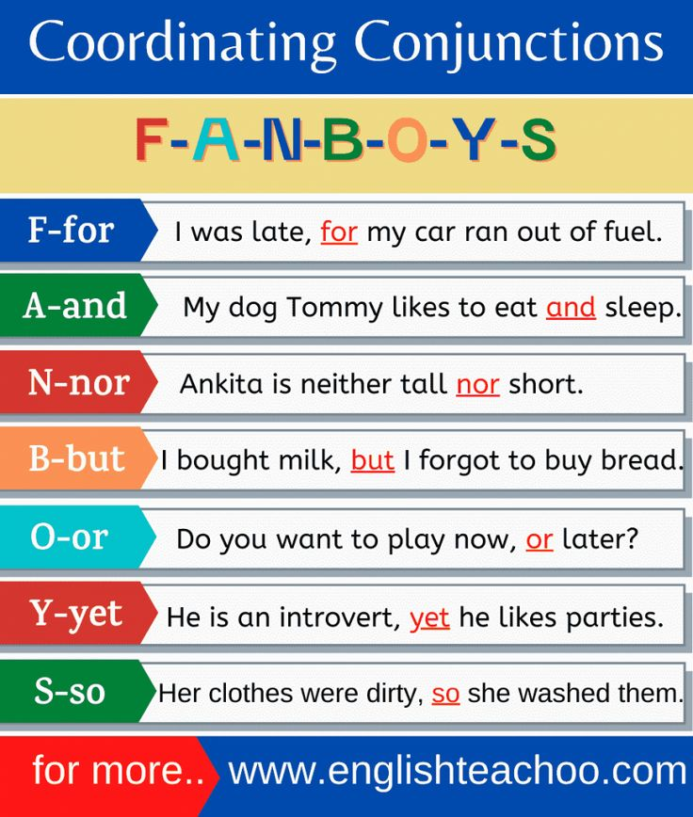
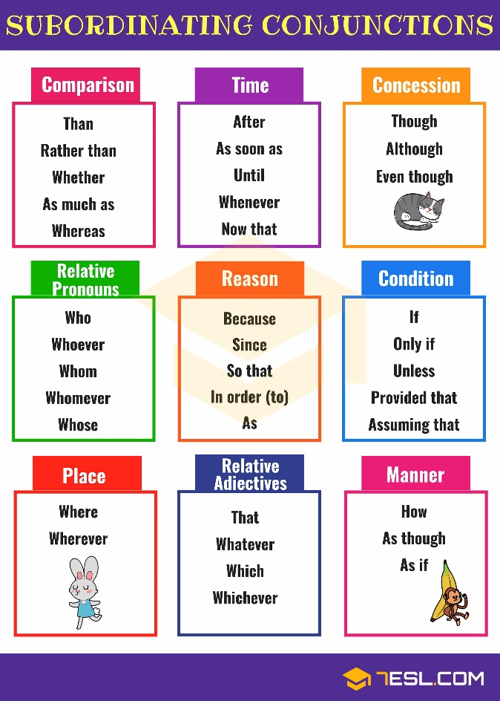

Tom and Jerry were creeping through the cold clammy cave when they suddenly heard rocks falling behind them. The underlined group of words is a/an ___________.
- Phrase
- dependent clause
- independent clause
- complex sentence

He loved and betrayed me.
- simple sentence
- compound sentence
- complex sentence
- compound-complex sentence

TAG QUESTIONS

Donny Pangilinan is a great actor, ________?
- doesn't he
- wasn't he
- isn't he
- is he

Tag Questions
Main Sentence Style | Tag Ending Style | Formula | Example
Positive (+) | Negative (-) | Matching Verb + not + Pronoun | Donny Pangilinan is a great actor, isn't he?
Negative (-) | Positive (+) | Matching Verb + Pronoun | Donny Pangilinan is not an amateur, is he?
Note: The verb should match (example: is, isn’t)

DEGREES OF COMPARISON

My bag is made out of ________ leather.
- Genuine
- more genuine
- most genuine
- least genuine

Absolute Adjectives (Non-Gradable)
They cannot form comparative or superlative degrees because you cannot have "more" or "less" of them.

Absolute Adjective | Why It Cannot Have Degrees | Incorrect Form | Correct Form
Dead | You are either alive or dead. | more dead / most dead | dead
Perfect | If it has flaws, it isn't perfect. | more perfect / most perfect | perfect
Unique | Unique means "one of a kind." | more unique / very unique | unique
Pregnant | You are either expecting a baby or you aren't. | more pregnant | pregnant
Genuine | It is either authentic or it is counterfeit. | most genuine | genuine

Degrees of Comparison
Degree of Comparison | What It Does | Common Formula / Clue | Practical Example
1. Positive | Describes one thing alone without comparing it to anything else. | Base adjective word | This is a heavy box.  She is a smart student.
2. Comparative | Compares exactly two things or groups. | Add -er at the end  OR use more / less | This box is heavier than that one.  She is more intelligent than him.
3. Superlative | Compares three or more things to show which one is the highest or lowest level. | Add -est at the end  OR use most / least | This is the heaviest box in the room.  She is the most intelligent student.

Comparison of Adjectives
Adjective Type | Positive | Comparative | Superlative
Short Adjectives  (1-2 syllables)  -er, -est | Big  Quick | Bigger  Quicker | Biggest  Quickest
Short Adjectives ending with -y  (y = i) | Pretty  Easy | Prettier  Easier | Prettiest  Easiest
Long Adjectives  (3 or more syllables)  More, most | Beautiful  Elegant | More Beautiful  More Elegant | Most Beautiful  Most Elegant

This is _________ typhoon in five years.
- a worse
- the worst
- the worsest
- most worst

QUANTIFIERS

Which of the following quantifiers modify plural nouns?
- many
- each
- every
- many a

Quantifier Rules for Nouns
Quantifier | Noun Type Modified | Grammatical Number | Example Sentence
Many | Countable | Plural | There are many books on the shelf.
Each | Countable | Singular | Each student received a certificate.
Every | Countable | Singular | Every house on this street looks the same.
Many a | Countable (Formal) | Singular | Many a politician has promised change.

FUNCTIONS OF SENTENCES

Which function of the sentence is exemplified in this sentence, "I want to learn how to create a web design."?
- imperative
- exclamation
- interrogative
- declarative

Sentence Functions
Sentence Type | Primary Function | Structural Characteristic | Standard Punctuation | Comprehensive Examples
Declarative | Makes a statement  Provides facts  Expresses opinions | Subject precedes the verb (Subject + Verb + Object). | Period (.) | The earth revolves around the sun. (Fact)  I think blue is the best color. (Opinion)
Imperative | Gives a command Makes a request  Offers advice | The subject "you" is implied (omitted). Starts with a base verb. | Period (.) or Exclamation mark (!) | Please close the door behind you. (Request)  Stop running in the hallway! (Command)  Take two tablets daily. (Advice)
Interrogative | Asks a direct question  Gathers information | Uses auxiliary verbs or "Wh-" words before the subject (Inversion). | Question mark (?) | Are you coming to the party? (Yes/No Question)  Where did you leave the keys? (Wh- Question)  You like coffee, don't you?
Exclamatory | Expresses strong emotion  Shows excitement/surprise | Often begins with "What" or "How" followed by a shift in word order. | Exclamation mark (!) | What a beautiful day it is! (Admiration)  How fast time flies! (Surprise)  We won the championship! (Excitement)
Optative | Expresses a wish  Formulates a desire/prayer | Often begins with words like "May," "Wish," or "If only." | Period (.) or Exclamation mark (!) | May you have a safe journey! (Blessing)  If only I were ten years younger. (Regret)  Long live the King! (Traditional Wish)

TENSES

Tenses
Tense | Subtype & Formula | When to Use (Function) | Time Markers | Example Sentences
Simple | Present  (Base verb) | Routine, facts, or habits | always, often, usually, everyday, each, every | I watch television everyday.  It snows in Alaska.
 | Past  (Verb + -ed or irregular) | A finished action at a specific past time | yesterday, last night, ago | I dreamt about you last night.  We went to Cebu yesterday.
 | Future  (shall/will + base verb) | Willingness, future plans, or predictions | tomorrow, next month, in the future | I will watch a movie tomorrow.  We will visit Cebu next month.
Progressive | Present  (are/am/is + -ing) | An ongoing action happening right now | right now, at the moment | I am talking now.
 | Past  (was/were + -ing) | An ongoing past action | when, while | I was eating when the phone rang.  I was watching TV while my sister was reading her book.
 | Future  (shall/will + be + -ing) | An ongoing action at a specific future time | at a specific future hour | I will be writing my paper at 9 tonight.
Perfect | Present  (have/has + past participle) | An action started in the past and completed by now | for 10 years, already | They have lived in LA for 10 years now.  I have already read Twilight Saga.
 | Past  (had + past participle) | An action completed before another past action | before, when | I had finished my homework before she arrived.  They had left when we got there.
 | Future  (shall/will + have + past participle) | An action completed before another future event | before a future deadline | She will have moved to a new apartment before the end of the month.  They will have completed the project before the deadline.
Perfect Progressive | Present  (has/have + been + -ing) | An ongoing past action continuing into the future | for two hours | I have been talking for two hours.
 | Past  (had + been + -ing) | An ongoing past action interrupted by another past event | when the power went out | She had been working for hours when the power went out.
 | Future  (will + have been + -ing) | An ongoing present action that will cross a future milestone | for a decade this January | We will have been living in Cebu for a decade this January.

Note: First look at the verb if it is present, future, or past then look for the following:
Will | -ing | Has/had/have + verb | Been + ing
FUTURE | PROGRESSIVE | PERFECT | PERFECT PROGRESSIVE

PRACTICE TIME

- They had finished the work before we arrived. PAST PERFECT TENSE

- I will be waiting for you at the station. FUTURE PROGRESSIVE TENSE
- By next month, they will have completed the project. FUTURE PERFECT
- She has been studying for three hours. PRESENT PERFECT PROGRESSIVE

CONDITIONALS

Conditionals
Category | Conditional Type | Situation / Purpose | Clue Words | Example Sentence
REAL | Zero Conditional | Facts, general truth, scientific facts  If + Present Simple, Present Simple | facts | Water boils if it reaches 100 degrees Celsius.
 | First Conditional | Possible in the future (Type 1 conditional)  If + Present Simple, will + base form of the verb | will | If we study, we will pass the test.
UNREAL | Second Conditional | If-clause + past simple + would + base form(V) | would | If I were in your place, I would talk to him.
 | Third Conditional | (Type 3) situations in the past, which did not happen and imagine the outcome of this situation (regret)  If clause + past perfect + might/could/would + have + past participle | Would have | If had studied harder, I would have passed the test.

Had I studied very well, I ____________ rewarded with a vacation in the US.
- was
- would have been
- will be
- would be

If I am free tomorrow, I will go with you.
- zero conditional
- first conditional
- second conditional
- third conditional

MOODS OF VERBS

On moods of verbs, which is expressed by the sentence, "I wish you were here"
- imperative
- subjunctive
- indicative
- interrogative

Verb Moods
Verb Mood | Situation / Purpose | Key Characteristic | Example Sentence
Indicative | States facts, opinions, and real-life assertions | Most common mood used in regular conversation | The sun rises in the east.
Imperative | Gives commands, direct requests, or advice | Omits the subject "you" and begins with a base verb | Please close the door.
Subjunctive | Expresses wishes, hypothetical scenarios, or demands | Uses base verbs or "were" regardless of the subject | I wish you were here.
Interrogative | Asks a direct question to gain information | Places auxiliary verbs before the subject | Are you coming to the party?
Conditional | Expresses an outcome dependent on a specific condition | Often relies on auxiliary verbs like would, could, or should | I would travel if I had money.

SUBJECT VERB AGREEMENT

Rules of S-V-Agreement
1. The orchestra plays a hit song.
Rule: Collective nouns (like orchestra) take a singular verb when the group acts as a single, unified unit performing the same action together.

2. The team are arguing among themselves.
Rule: Collective nouns (like team) take a plural verb when the individuals within the group are acting separately or are in conflict (indicated by the clue among themselves).

3. The information is relevant to my study.
Rule: Non-countable/mass nouns (like information) are always grammatically singular and require a singular verb.

4. Three sacks of rice are heavy.
Rule: When a quantity phrase has an "of" modifier, the verb agrees with the countable head noun (sacks, which is plural) rather than the mass noun inside the phrase (rice).

5. The news was fake.
Rule: The word news looks plural because it ends in "-s", but it is an uncountable noun that is strictly singular in construction.

6. Pliers are used for electrical work.
Rule: Tools, instruments, or articles of clothing consisting of two parts joined together (like pliers, scissors, pants) are inherently plural and take plural verbs unless preceded by the phrase "a pair of".

7. Six plus six equals twelve.
Rule: Mathematical operations and equations (addition, subtraction, multiplication, division) are treated as singular units and take a singular verb.

8. Everything happens for a reason.
Rule: Indefinite pronouns ending in -thing, -one, or -body (like everything, someone, anybody) are always grammatically singular and require a singular verb.

9. Few participants are expected to convene after workshop.
Rule: The indefinite pronouns few, both, many, several, and others are always plural and require a plural verb.

10. None of them avoid the traffic.
Rule: When using none of followed by a plural countable noun or pronoun (them), a plural verb is typically used in modern English and standardized board exams because it refers to multiple individuals within that group.

11. One half of the information is irrelevant.
Rule: For fractions, percentages, or partitive expressions, the verb agrees with the noun following the word "of". Since information is a non-countable noun, it takes a singular verb.

12. The Malaya creek or the surrounding rivers are sources of plastic wastes.
Rule: When two subjects are connected by or or nor, the verb must agree with the subject closest to it. Since the surrounding rivers is plural, the verb must be plural.

13. Not only the father but also the siblings are also in opposition to this.
Rule: When subjects are joined by correlative conjunctions like not only... but also, the verb must agree with the subject closest to it. Since the siblings is plural, the verb is plural.

14. Here come my friends.
Rule: In sentences beginning with here or there (expletives/inverted word order), the true subject follows the verb. Since my friends is a plural subject, it takes the plural verb come.

15. Bacon and egg is my favorite breakfast.
Rule: When two nouns joined by and represent a single combined idea, entity, or dish (indicated here by the singular phrase my favorite breakfast), they take a singular verb.

16. It is the leader, not his members, that has opened the plenary.
Rule: The relative pronoun that refers back to its true antecedent, the leader (singular). Intervening parenthetical phrases set off by commas (like not his members) do not affect the number of the true subject.

17. The student, together with her classmates, studies the lessons well.
Rule: Parenthetical expressions introduced by words like together with, along with, as well as, or accompanied by do not alter the number of the subject. The true subject is The student (singular), so the verb must be singular.

18. The rich are getting richer.
Rule: When an adjective is preceded by the article the to represent a whole class or group of people (such as the rich, the poor, the young), it functions as a plural noun and requires a plural verb.

ORDERS OF ADJECTIVES

Categories of Adjectives in Order (OS-PQ-SACOM-TP)
Order | Adjective Category | What it Relates to | Examples from Slide
1 | Opinion | Explains what you think of something | unusual, lovely, beautiful
2 | Size | Describes how big or small something is | big, small, tall
3 | Physical Quality | Describes texture, state, or surface quality | thin, rough, untidy
4 | Shape | Describes the form or geometry | round, square, rectangular
5 | Age | Describes how old or young something is | young, old, youthful
6 | Color | Describes the shade or pigmentation | blue, red, pink
7 | Origin | Says where something comes from | Dutch, Japanese, Turkish
8 | Material | Says what something is made of | metal, wood, plastic
9 | Type | Explains the specific kind or category | general-purpose, four-sided, U-shaped
10 | Purpose | What the object is used for (often ends in -ing) | cleaning, hammering, cooking

VOCABULARY

She is a vision of feminine "pulchritude" This stands for the following EXCEPT
- loveliness
- comeliness
- homeliness
- physical beauty

Synonyms
Word | Synonym / Meaning
penchant | fondness
transmuted | changed
impertinent | irrelevant
esoteric | understood by few
candor | frankness
rancor | bitter / bitterness
sine qua non | essential
skeptical | doubtful
kikay | flirtatious
apocalyptic | prophetic
aplomb | composure
profanity | obscenity / swearing
loquacious | talkative
baduy | awkward looking
ubiquitous | present everywhere
sycophant | boot-licker/ flatterer

The courage of the child who saved his brother from a raging fire is worth __________.
- emulating
- mentoring
- narrating
- watching

IDIOMS

You eat like a horse when you _________.
- get used to something new
- drink large quantities of alcohol
- have a healthy appetite
- run fast

"My mother has a green thumb. I can't wait to show you her garden." What is the equivalent meaning?
- She grows a vegetable garden.
- She cultivates a garden.
- She takes care of flowering plant.
- She is good at gardening.

Idioms
Idiom | Simple Meaning | Example Sentence
eat like a horse | Regularly eat large amounts of food / have a large appetite | He eats like a horse but never seems to gain any weight.
have a green thumb | Natural talent or skill for growing plants and gardening | My mother has a green thumb; her garden is always beautiful.
hit the nail on the head | Say or do something exactly right | You hit the nail on the head with that answer.
piece of cake | Extremely easy to do | The grammar exam was a piece of cake.
cost an arm and a leg | Very expensive | That brand new smartphone costs an arm and a leg.
bite off more than you can chew | Take on a task that is too big or difficult | Don't bite off more than you can chew by taking five classes.
beat around the bush | Avoid speaking directly about the main topic | Stop beating around the bush and tell me the problem.
let the cat out of the bag | Reveal a secret by accident | We planned a surprise party, but Sarah let the cat out of the bag.
first rate | Excellent or of the highest quality | The service at this restaurant is absolutely first rate.
sixes and sevens | A state of confusion, disorder, or disagreement | The office files were all at sixes and sevens after the move.
white elephant | A costly possession that is useless or troublesome to maintain | The new stadium turned out to be a massive white elephant.
burn the midnight oil | Work or study late into the night | I have to burn the midnight oil to prepare for my board exam.
catch someone red-handed | Catch someone in the middle of doing something wrong | The security guard caught the shoplifter red-handed.
two peas in a pod | Two people who are very similar in appearance or behavior | Those twin brothers are like two peas in a pod.
straight from the horse's mouth | From the highest or most reliable authority directly | I know she is resigning because I heard it straight from the horse's mouth.
elephant in the room | An obvious problem or difficult situation that people avoid talking about | Nobody wanted to mention his demotion; it was the elephant in the room.

If you forgot _______ textbook, you can use_________, Anya.
- yours, ours
- your, mine
- myself, ourselves
- ours, hers

Marites _____ in bed too long and missed her classes.
- Laid
- Lays
- Lay
- lied

Verb Meaning | Present Tense | Past Tense | Past Participle | With an Object? | Example Sentence
Lay  (To put/place down) | Lay / Lays | Laid | Laid | Yes + Object  (You do it to something) | She laid the books on the table.
Lie  (To recline/rest) | Lie / Lies | Lay | Lain | No Object  (You do it yourself) | Yesterday, Marites lay in bed too long.
Lie  (To untruth) | Lie / Lies | Lied | Lied | No Object | He lied about his test scores.

Which of the following statements is a fact rather than a mere opinion?
- After visiting the Philippines, the tourists will say "wow".
- Tourism generates revenues from foreign visitors.
- Tourism visits will continue to grow in spite of bad years
- Visiting the Philippines is fun.

